In order to better serve the research and academic community, the Managers of the Orange County Marine Protected Areas are working to streamline the permitting process for school group use of the rocky intertidal zone. Please complete the following form and email it to the area manager at least 30 days in advance of requested use dates.

Before planning your class field trip, please read the rules and regulations regarding usage of the rocky intertidal zones within Orange County Marine Protected Areas. Regulations include NO collecting of any type, NO turning over rocks, NO handling, and NO walking in tidepools and other delicate areas. All visiting school groups must complete this form.

Name of School/Organization:
Address:
Contact Person (Responsible for Field Trip):
Contact Email: Contact Phone:
Proposed Date(s): Time: # Students
Grade Level:

Marine Protected Area(s):

Newport Beach Crystal Cove Laguna Beach Dana Point

Upper Newport Bay Bolsa Chica/Bolsa Bay

Specific Area(s)/Site(s):

I attest that all of the above information is correct: Signature: Date:

MPA Manager Approval:

Approved: Yes No MPA Manager Signature: Date:

Notes: Please print a copy to have available to show to Tidepool Educators upon request. Thank you.

The Good Tidepooler Rules are:

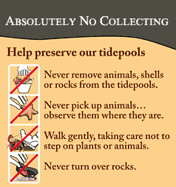

Safety Tips:

- Wear closed toed shoes.
- Be aware of the ocean. Never turn your back on large waves and know the times and heights of incoming tides.
- No running across rocks or mussel beds.
- Notify a lifeguard or call 911 if you see someone in danger of washing off the rocks or witness a medical aid.
- Never jump in to rescue a student or an assistant. Call a lifeguard!
- Use sunscreen and wear sun protective clothing (hat, long sleeve shirt) whenever possible.
- Be careful not to become dehydrated – drink plenty of water.

