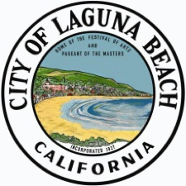

M E M O R A N D U M

**TO:** Interested Laguna Beach Residents, project applicants, designers / architects, and others

**FROM:** City of Laguna Beach Community Development team, including the City Manager and City Attorney’s Office

**RE:** Proposed Changes to Design Review and related parts of the Laguna Beach Municipal Code (“LBMC”)

**DATE:** October 17, 2024

**SUMMARY:** In an attempt to both meet the goals of the City’s **Housing Element** (2021-2029, see Attachment A) and to address larger concerns about **delays and the slow pacing of project approvals,** City staff has identified changes to specific parts of the LBMC that relate to Community Development (generally but not exclusively to the Design Review or “DR” pathways). The proposed changes have been crafted with the primary goal of expediting reviews and processing while maintaining the spirit of Laguna Beach’s DR tradition – in part by reducing the bureaucracy and other items that can lead to mistakes.

**KEY DEFINITIONS / CONCEPTS:**

* **“Exempt from DR”** means a project that does not require any level of design review, such as an interior remodel of an existing building. This type of project typically requires a building permit only.
* **“Admin DR”** means DR that is handled via a review of the project and the code administratively (i.e. by designated city staff). In other words, without a hearing of the **Design Review Board** (“DRB”) or **Planning Commission** (“PC”). Admin DR may include a public hearing where members of the public are invited to attend and speak with the applicant and the person holding the hearing. The person holding the hearing would be a Community Development staff member, such as the department director or their designee.
* **“Historic Register”** means our **formal listing** of historic resources – public and private – where property owners agreed to have their property listed on a formal register in exchange for certain benefits, such as property tax reductions under the Mills Act.
* **“Non-Register Properties”** refers to properties not listed on a Historic Register, including properties previously listed on an Historic Resources Inventory prepared in the 1980s that is no longer referred to or recognized in the LBMC. In some cases, City staff may have to do some level of review under the California Environmental Quality Act (CEQA) to evaluate the historicity of Non-Register Properties. This is because state law (CEQA) requires analysis of impacts to qualifying historic resources, and any proposed development that is subject to discretionary review, such as through DR or Admin DR, requires that the project be reviewed for compliance with CEQA.

**PROPOSALS:** Our proposals address these four (4) areas:

1. **Triggers for Design Review.** In other words, the types of projects that must go through some level of design review process. We’re proposing these categories or “buckets” of changes:
   1. A larger change **in approach** that reduces the breadth of DR. Our changes would state that DR is required for projects clearly identified by the LBMC as needing DR, versus requiring DR for all projects unless otherwise called out as “Exempt from DR” or subject to “Admin DR.” The below illustrates the change (Current and Proposed):

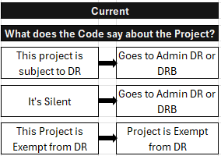

* 1. Adding to the types of projects that are **Exempt from DR.** These include, but are not limited to (generally):
     1. Changes that do not constitute a major remodel, as defined.
     2. Improvements less than 16’ above adjacent ground elevation.
     3. Interior modifications to existing structures.
     4. Exterior changes to a front façade that *don’t* result in a style change.
     5. Re-roofing projects that *don’t* change the slope, roof dimensions, square footage, or pitch and that don’t create a reflective glare.
     6. Certain hardscape and landscaping.
     7. Fences, walls, and hedges that are consistent with the LMBC.
     8. Decks, slabs, or patios elevated 3’ or less above the existing grade.
     9. Railings.
     10. Skylights with operable night shades.
     11. SB 9 units, only as limited by the Code.
     12. Mechanical equipment that meets noise and other requirements.
     13. De minimis capital improvement projects.
     14. Swimming pools, spas, and water features[1].
  2. Changes that move certain projects from **full** **DRB review** to **Admin DR** – i.e. adding to the types of projects that can have their DR addressed by City Staff versus the DRB. During the application process, an administrative public hearing can be held if neighbors ask for the hearing after receiving appropriate notice. If neighbors are noticed and do not respond, **the project is approved without a public hearing**. These include, but are not limited to (generally):
     1. Exterior changes to a front façade that result in a style change.
     2. Certain landscaping.
     3. Decks, slabs, or patios elevated more than 3’ above the existing grade.
     4. Minor alterations to historic resources, when the alterations are in conformity with the US Secretary of the Interior’s *Standards for Treatment of Historic Properties*.
     5. Re-roofing projects that change the slope, roof dimensions, square footage, or pitch or that do result in white or light-colored roofs.
     6. Detached fireplaces.
     7. The addition of skylights without operable night shades.
     8. Telecommunications facilities.
     9. Above-ground utility structures.
     10. Certain minor capital improvement projects.

The Community Development Director may **refer Admin DR projects to the full DRB** or Planning Commission if the Director deems it appropriate.

1. **Consolidating Design Review Criteria.** We propose consolidating 15 DR Criteria into 7 DR Findings and making one criteria (Swimming Pools, Spas, and Water Features) subject to objective standards in the Code. Staff views this as a non-impactful change that protects DR overall, but helps staff operate more efficiently and avoid mistakes and delays. There is a rigidity to the current structure that limits the ability of DRB and PC to collaborate and approve concepts during a hearing as, under the current system, staff struggles to ensure that there are written facts and findings for each criteria.

The seven proposed categories are (along with the criteria that would fall into the categories):

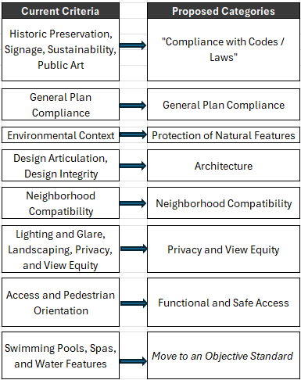

1. **Other and Miscellaneous Changes.** In some cases, the City’s processes and codes are inconsistent with recent changes to State law or can add to inefficiencies that slow project considerations. In other cases, design guidelines appear in multiple sections of the LBMC within neighborhood reference sections (where they are arguably not needed). We are also taking this opportunity to improve our transparency with the public by clearing up ambiguities in the LBMC. In many cases, these code ambiguities are resolved through policy interpretations that have been rendered over the years. Today, that can mean that correct code interpretations may rely on institutional knowledge (yours and ours) to navigate the development process. These changes include:
   1. A new limitation on applications to 2 DRB or 2 PC hearings and a prohibition on resubmittals on the same parcel for six (6) months; and
   2. Removal of some duplicative language in other sections of Title 25 that apply the same or similar design guidelines.
   3. Rewording of some development standards and other key code provisions for clarity to improve consistency in how planning staff and design professionals are interpreting and applying requirements to projects.
2. **Improvements to our Historic Resource Management**. These changes are not all LBMC code changes and include process and staffing changes that attempt to improve how the Community Development staff treats properties that are determined to be or may be a qualifying historic resource. They include:
   1. *Administrative Improvements*
      1. **Register**. Files for properties on the **Historic Register** would be researched and reviewed for appropriate documentation, along with an action plan for any anomalies in the files.
      2. **Non-Register Properties.** With a consultant’s assistance, a system will be created to assist staff in reviewing pending applications for Non-Register Properties to evaluate evidence of historicity to determine whether the property falls within the definition of a qualifying historic resource for purposes of CEQA.
      3. **Preservation Planner.** We’re also proposing to engage a full time, part time, or consultant position qualified to regularly address historic preservation issues as project applications come in.
      4. **Review of the Heritage Committee’s role.** This includes consideration of a specific Heritage Committee workplan, as well as consideration of morphing the Committee into a Commission that has DR authority over Register properties (in this model, Register properties would no longer go through DRB or PC review but would go to a new Heritage Commission).
   2. *Code Changes*
      1. **Minor property alterations of Historic Properties**. These would be approved via Admin DR provided that the proposed changes are consistent with the US Secretary of the Interior’s *Standards for Treatment of Historic Properties.* The proposed alterations would be considered at a public hearing if requested by a neighbor.
      2. **Major property alterations of Historic Properties**. These would be defined and would require Heritage Committee review and approval only at a public hearing.
      3. **Historic Resource Assessments:** The Code would clarify that, depending on the property, historic resource assessments may be required prior to project review and paid for by:
         1. The City (where City is not confident that the property is a historic resource).
         2. The Applicant (where City is confident that the property is a historic resource).

**How You can Weigh In.** If you want to delve deeper into the proposed changes, please see the linked attachment, which is a redline version of how the LBMC’s Title 25 might change.

Please provide any feedback to us by **Thursday, November 14, 2024.** Please use the fillable form on the City’s website.

**Attachments:**

* Attachment A: What the City of Laguna Beach’s 6th Cycle Housing Element (2021-2029) says about Design Review and Permit Streamlining
* Attachment B: Redline version of aspects of the LBMC

**Attachment A**

*From the City’s Housing Element (2021-2029)*

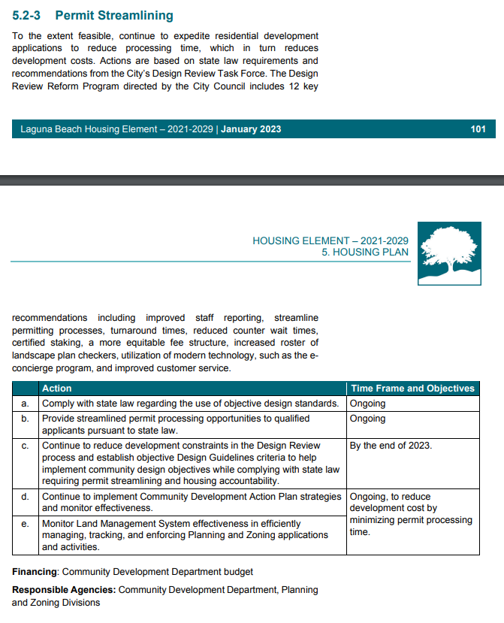

**Attachment B**

*Proposed Redline of Changes to the LBMC*

1. Such projects may be subject to a coastal development permit exemption or to an administrative coastal development permit.