
Laguna Beach Animal Shelter
20612 Laguna Canyon Rd.
Laguna Beach CA, 92651
(949) 497-3552

Solving Your Barking Dog Problems

A constantly barking dog can be a real problem; Laguna Beach Police Department Animal Services is here to work with you to try to get that problem under control.

When you have a barking dog complaint, an Animal Services Officer (ASO) will come out and leave a Courtesy Notice for the owner of the offending animal. Very often this action alone will prompt the pet owner to take appropriate measures to insure that their animal will no longer disturb the neighborhood. Sometimes however further action is needed.

For legal action to be taken an Animal Services Officer needs to leave three Courtesy Notices in no more than a four month time period. If the pet owner has not responded after the third notice then you may opt to have a police officer come out and issue a “Citizens Citation” on your behalf. Both you and the pet owner must be present in order for the citation to be issued. Once the citation has been issued a court date will be set and you and the pet owner will appear before a judge.

While this may seem like a long and inconvenient process you must remember that the Orange County District Attorney’s office has tens of thousands of cases to review and our Judges will each hear hundreds of complaints each year. Your willingness to participate in the process shows that your complaint is serious enough for their consideration.

Another option you may choose is mediation. This is a process where, for a relatively small fee, a third party (not associated with the Police Department) will moderate your dispute and help you and the pet owner come to some kind of acceptable agreement. Many neighbors have been able to settle their differences satisfactorily through mediation.

Unfortunately Animal Services cannot repeatedly respond to your barking dog complaint if you are not willing to take the next step. If after the third notice, you are not willing to have a citation issued in your name, Animal Services will be forced to close the file on your case.

Before you take action you should decide if the barking is truly a problem.

- Keep a log – Make an entry whenever the dog barks. List details of the occurrence including the date, time, and duration.

- Identify patterns – Does the dog bark constantly between 9 – 5 Monday through Friday? Is it only when the pet owner goes out for the evening? Having this information will be helpful to the animal services officer as well as the pet owner.

- Identify triggers – Is something setting the animal off like the trash man, mailman or the street sweepers, or does any little thing start the dog barking?

- Identify circumstances – Has the dog just started barking since construction started in your neighborhood, does it mostly happen on the weekends or after school when neighborhood children are at play?

- Talk to your neighbors - Find out if the pet in question is bothering other people on your block.

- Start a neighborhood petition – This should include each signatories printed name, address, phone number as well as their signature.

If you find that the animal in question isn’t bothering anyone else or that it may be barking for legitimate reasons, you should reassess your motives. Is your complaint actually about a barking dog or is this really a dispute about something else? An illegitimate claim may have long ranging negative effects.

For Further Information contact Laguna Beach Police Department / Animal Services at (949) 497-0701 ext. 0
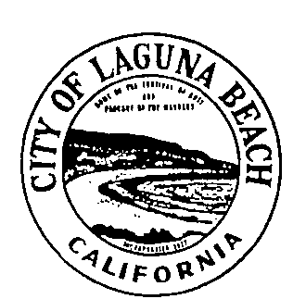
Laguna Beach Police Department
Animal Services
505 Forest Avenue
Laguna Beach, CA 92651
(949) 497-0701

